COMMITTEE INFORMATION
Co-Chairs: Holly Bill (hbill@hulthealthy.org) and Tim Bromley (tim.d.bromley@osfhealthcare.org)
Support Person: Amy Roberts (aroberts@peoriacounty.org)

Useful Resources:
- Partnership for a Healthy Community Website: https://healthyhoi.wildapricot.org/
- Meeting Information and Data Tracking: Data sheets will be shared at each meeting by data support person, Amanda Smith
  - Mental Health https://healthyhoi.wildapricot.org/2020-22-Mental-Health
  - Substance Use: https://healthyhoi.wildapricot.org/2020-22-Substance-Use
- Discussion Boards: https://healthyhoi.wildapricot.org/discussions

AGENDA

- Introductions
- Dashboard & Data Updates (See attached dashboards & Pages 4&5)
- CHNA & CHIP Next Steps
  - CHNA Process & Planning
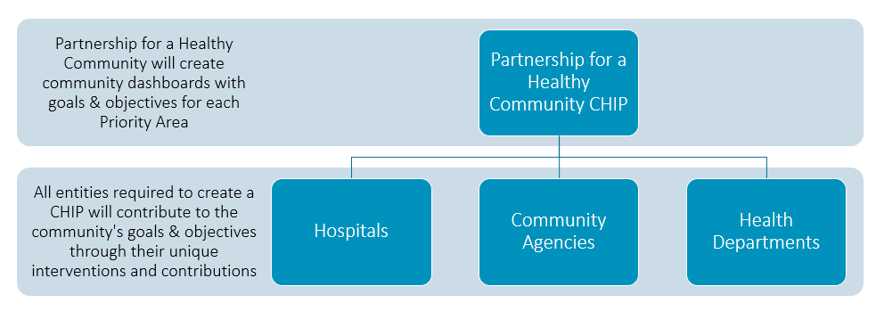
  - 2023-2025 Priority Health Areas Selected- Healthy Eating & Active Living, Mental Health, Obesity (See attached data sheets)
    - Cancer and Substance Use- will move to Performance Management for 2023-2025
      - Open Dialogue: Ideas on how to move forward with Substance Use?
        - Will need a chair to continue meetings for next three-year cycle (Jan 2023-Dec 2025)
    - CHNA Process & Planning

    - CHIP Planning Dates- October 10th (Obesity), 11th (HEAL), & 12th (Mental Health) from 8:30 AM – 12:00 PM at OSF Spalding Center; all committee members should have received an invite, please RSVP and let Amy Roberts know if you plan to attend or not

- Action Teams Updates

Objective | Update | Action Items/Follow-Ups
Increase Mental Health First Aid Certifications by 10% (Joan Montoya) |  | If you are interested in being trained or hosting a training for you agency please visit Partnership for a Healthy Community - Mental Health & Youth Mental Health First Aid Trainings (wildapricot.org)
Increase suicide prevention education for youth and adults by 10% (Hannah Chapman/Mike Kennedy) |  | Please let the team know if you are interested in joining this group or know of any other suicide prevention/postvention resources that serve tri-county.
Increase number of trauma informed schools by 10% (Michele Carmichael) |  | Please visit this link to view updates for this group: Partnership for a Healthy Community - Trauma-Responsive Schools (wildapricot.org)  If you are interested in the free trauma trainings please visit the virtual learning community here: REACH Learning and Resource Hub — Center for Childhood Resilience
Increase behavioral health integration by 10% (Tim Bromley) | No updates at this time.
Reduce overdose through Narcan by increasing distribution by 10% (Elizabeth Hensold/Katy Endress) |  | Opioid Awareness (arcgis.com)
Increase stable housing for frequent utilizers (Kate Green); Frequent Utilizers & Crisis response (Kelly Walsh)

Increase number of schools who participate in Rx Drug Safety

Mass media campaigns for binge drinking and underage drinking (Kerri Viets)

Increase number of students certified as Peer Educators by 10% (Holly)

- Updated Meeting Structure: Every other month- Full committee/Sub-committees; Schedule posted on healthyhoi.org
2022 Meetings
January 31, 2022 - Virtual Meeting
February 2022 - No Committee Meeting; Priority Action Team Meetings Only
March 28, 2022 - Virtual Meeting
April 2022 - No Committee Meeting; Priority Action Team Meetings Only
May 23, 2022 - Virtual Meeting
May 24, 2022 – Annual Meeting of Partnership Board
June 2022 - No Committee Meeting; Priority Action Team Meetings Only
July 25, 2022 – Virtual Meeting
August 2022 - No Committee Meeting; Priority Action Team Meetings Only
September 26, 2022 – In-person meeting at Peoria City/County Health Department Room 125 (no virtual option for this meeting)
October 2022 - No Committee Meeting; Priority Action Team Meetings Only
November 28, 2022 - TBD Meeting
December - NO MEETING - HOLIDAY BREAK

- Next Meeting Date:
  - Monday, November 21, 2022 OR Monday, November 28, 2022?
  - Teams OR In-Person?
  - Substance use representatives cannot attend Monday mornings; is everyone able to move the meeting to Monday afternoon?
  - Please tentatively hold Monday, October 24th for CHIP Planning if needed
- Member Announcements: Please feel free to share relevant information & announcements

DATA UPDATES as of 9/19/22
- Did we decrease the number of suicides? Suicides were not decreased, in fact, increased for all three counties and the state of Illinois.
  - (2015 to 2016-2018: PC = 10.9 to 16.2; TC = 12.0 to 14.7; WC = 15.8 to 17.7; IL = 9.5 to 11.1) (IDPH)
- Did we decrease the number of residents who reported feeling depressed? No, results of the 2022 CHNA show a 12% increase in the number of people experiencing depression and a 12% increase in the number of people experiencing stress / anxiety, compared to 2019 (CHNA, 2022).
- Did we reduce the rate of drug-induced deaths? Peoria decreased; Tazewell and Woodford increased.
  - (2019/2020/2021: PC = 26.81/22.09/22.29; TC = 14.00/19.62/27.60; WC = 5.17/12.99/13.08) (Vital Records OD Data)
- Did we increase the proportion of adolescents reporting never using substances in the tri-county area? No, all three counties decreased reporting ever using substances.
  - (2019/2020/2022 - PC = 33%/25%/27%; TC = 29%/33%/26%; WC = 20%/30%/11%) (Illinois Youth Survey)
- Did we reduce the female breast cancer death rate? Peoria and Woodford decreased; Tazewell increased.
  - (2011-2015/2014-2018/2015-2019: PC = 22.7/19.7/20.6; TC = 18.7/19.9/20.6; WC = 24.4/26.7/22.9)
- Did we reduce the colorectal cancer death rate? Yes, all three counties decreased.
  - (2011-2015/2014-2018/2015-2019: PC = 17.6/10.5/11.6; TC = 17.6/12.7/13.8; WC = 20.7/15.0/12.1) (National Cancer Institute)
- Did we reduce the lung cancer death rate? Yes, all three counties decreased.
  - (2011-2015/2014-2018/2015-2019: PC = 86.9/42.8/39.2; TC = 84.3/43.3/41.8; WC = 56.6/38.5/36.9) (National Cancer Institute)
- Did we reduce the proportion of adults considered obese? No, Peoria and Woodford increased; Tazewell stayed the same.
  - 2022 CHNA-In Peoria County, the number of people diagnosed with obesity and being overweight has increased slightly over the years from 2010-2014 to 2015-2019. Tazewell County has seen a decrease in the number of people diagnosed with being overweight and obese going from 66.1% to 64.8% in 2019. Woodford County has also seen a decrease in 2010-2014 from 69.4% to 64.8% in 2015-2019. Note specifically that the percentage of obese and overweight people has increased from 63.7% to 65.7% for the State of Illinois (2019/2020/2021/2022 = PC= 33%/36%/39%/39%; TC = 33%/33%/30%/33%; WC = 28%/27%/31%/32%) (County Health Rankings)
- Did we reduce the proportion of youth who self-reported as overweight and obese? The data varies across counties and age groups; please see data below:
  - Grade 8: 2019/2020/2022 = PC = 25%/23%/27%; TC= 27%/25%/31%; WC = 21%/23%/NA)
  - Grade 10: 2019/2020/2022 = PC = 31%/30%/30%; TC= 29%/30%/29%; WC = 26%/22%/NA)
  - Grade 12: 2019/2020/2022 = PC = 23%/37%/25%; TC= 26%/28%/26%; WC = 21%/23%/NA) (Illinois Youth Survey)

