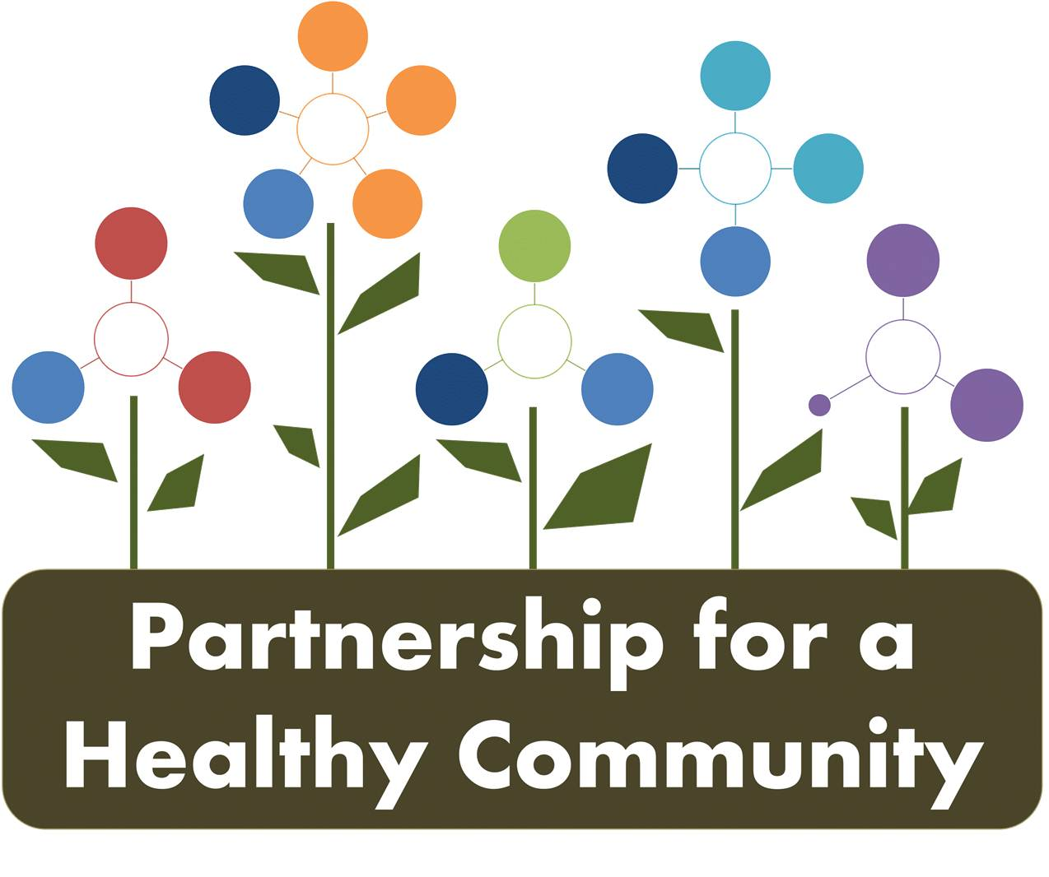
Breast and Lung Cancer Action Team-Quarterly Meeting
Tuesday June 18, 2019 2:00-3:30 PM
Tazewell County Health Department
In Attendance:
Julie Angle- Lung Cancer/Tobacco Action Team Co-Chair, Tazewell County Health Department
Greg Eberle-Breast Cancer Action Team Chair, Hopedale Wellness Center/Medical Complex

Hillary Aggertt-Woodford County Health Department
Katie Fassig-Tazewell County Health Department
Melissa Goetze-Tazewell County Health Department
Kim Gudzinskas-Tazewell County Health Department
Rachel Hensold-Woodford County Health Department
Julie Herzog-Tazewell County Health Department
Andrea Ingwersen-Woodford County Health Department
Jessica Johnson-Hult Center for Health Living
Nicole Robertson-Methodist College
Diana Scott, Peoria City/County Health Department
Michele Sharping-Tazewell County Health Department
-No call in participants

-Julie Herzog made a motion to approve March 2019 Quarterly meeting, Hillary Aggertt seconded.

P4HC Board updates and prioritization for 2020:

Hillary reported to the group that the board is finalizing structure for the 2020 cycle. An impact report will be created, a summary of the last 3 years of work form each action team. Each action team will submit one by the end of 2019.

PH4C will be “rebooting” at the beginning of the next cycle, with each action team being led by a representative from a health department, hospital and a community lead (for each priority). Meetings will take place to discuss the “reboot” and will be separate from currently scheduled action team meetings.
Meeting and reporting were discussed: Diana agreed to continue to do dashboards for each priority as a way keep all information and action team progress in one place.

-Julie Angle reported that ITFC grantees meet individually and then report that work to partnership as part of the requirement for a community coalition.

-Radon has a grant and uses the action team to assist with activities and reports to the action team.

-Hillary stated that most votes were to keep the action teams together, one meeting. She said the structure is not finalized as there will be new leads and new members in the next cycle.

Communication and website: Discussion took place about the current website, and that it is underutilized to communicate between action teams. Other platforms are being discussed that may be easier to use, and update regularly.

-each dashboard should be added to the website as a working document that can show priority/action team progress.

-minutes should also be added to the website and hopefully the new platform will reduce barriers to post supporting documents. The website should also give general position and guidance for each priority team, and any interested community member.

-Perhaps a easier to use website platform would help the Cancer priority teams work better together and not silo themselves; should be working together for all 3 priorities, aligning resources, and community members

-All 3 priorities should be working together

Hillary discussed the Partnership data group and how that group is working to support the priority action team’s work; she asked what data needs there were, what we currently have and what needs to start being gathered or measured.

Breast Cancer:

BC positon statement was distributed by OSF marketing to their providers and by IBCCP Coalition. Beyond that and the news release, not sure the position statement was distributed as it should’ve been.

-Greg stated he would follow up with some contacts for distribution of breast cancer position statement and also send invites for new members to attend meetings.

-Discussion ensued about other ways to distribute and use as a tool to invite news members; insurers? Hospital billing (Kim G. will contact), Heartland clinic (Julie H. will contact).

The team discussed screening numbers and importance of continuing to gather those in the future.

Lung Cancer/Radon:

The radon position statement was discussed, what the purpose should be. Who is the audience? Diana created a rough draft and it will be distributed to the lung action team for feedback and to discuss at the August meeting.

-TCHD reported that since January 2019, 163 radon kits have been sold.

-30/60/90 day plan for radon grant was discussed; position statement will be worked on and the action team will support strategic plan of current grant.

-TCHD still working on resource guide, added to 90 day plan and to radon dashboard. TCHD has new website platform, and needs time to post the resource guide. It can also be posted on Partnership website when the new platform is determined. All agreed distribution of the guide would be group work once it is completed. Each agency individual page can have a link to the Partnership website for the resource guide if that would be easier for now.

-2.4 -dashboard were updated and data collection was discussed, whether HDs can collect zip code data for radon kits they sell to public. Hillary will follow up with IEMA for clarification. Need to collect # of test kits sold and # that needed mitigation/or # that were mitigated.
Can the action team advocate for IEMA to update their website? Does IEMA have a marketing person or plan?

3.3a Workforce capacity was discussed. Need to collect the following: # of mitigators in tri-county area? Wait time for homeowners? Perhaps Jim can assist or provide direction on this dashboard item.

Lung Cancer/Tobacco:

Illinois Tobacco Free Communities- 20 policies total for tri-county. 13 campuses, 4 outdoor space and 3 multi-unit housing.

-grantees created the tagline “ Live, Work and Play Tobacco-Free in Peoria, Tazewell and Woodford Counties” for outreach materials and are working together as a region to streamline messaging and share resources while promoting grant deliverables. This work will continue into the next grant year, the 2nd year of the regional grant.

-Tazewell: working with safety committee to make all county owned properties tobacco free. Tazewell County insurance covers cessation services for employees.

-Peoria and Woodford: Health departments properties are tobacco free but not all county owned properties.

-Discussion regarding smoke-free vs. tobacco-free and why the regional grantees decided to promote tobacco-free.

-Julie Herzog gave an update about AOK smoking during pregnancy prevention initiative. For the FY ’20 grant, AOK will be working with home visitor programs to give resources to pregnant smokers, with the ultimate goal of reducing the number of TC pregnant mothers that report smoking. Julie gave the group details about new digital ads.

-The group discussed prompting the Illinois Tobacco Quitline and if it would be possible to have a representative attend of a meeting or call in to give a presentation or a “walk-through” of what someone calling for assistance in quitting tobacco products would experience. A kind of “train-the-trainer” presentation to better understand and promote the Quitline.

Announcements:

Nicole Robertson explained her role with Methodist College and the mobile community-based care van “Mollie.” Post-graduate nurses can earn 30CE credits and partner with community agencies to provide community primary care. Nurses can complete 4 modules over 4 months.

Next meetings:

Breast Cancer Action Team: Tuesday, August 13th, 2019 2:00-3:30pm at Peoria City/County Health Department

Lung Cancer Action Team: Thursday, August 8th, 2019 2:00-3:30 at Woodford County Health Department

