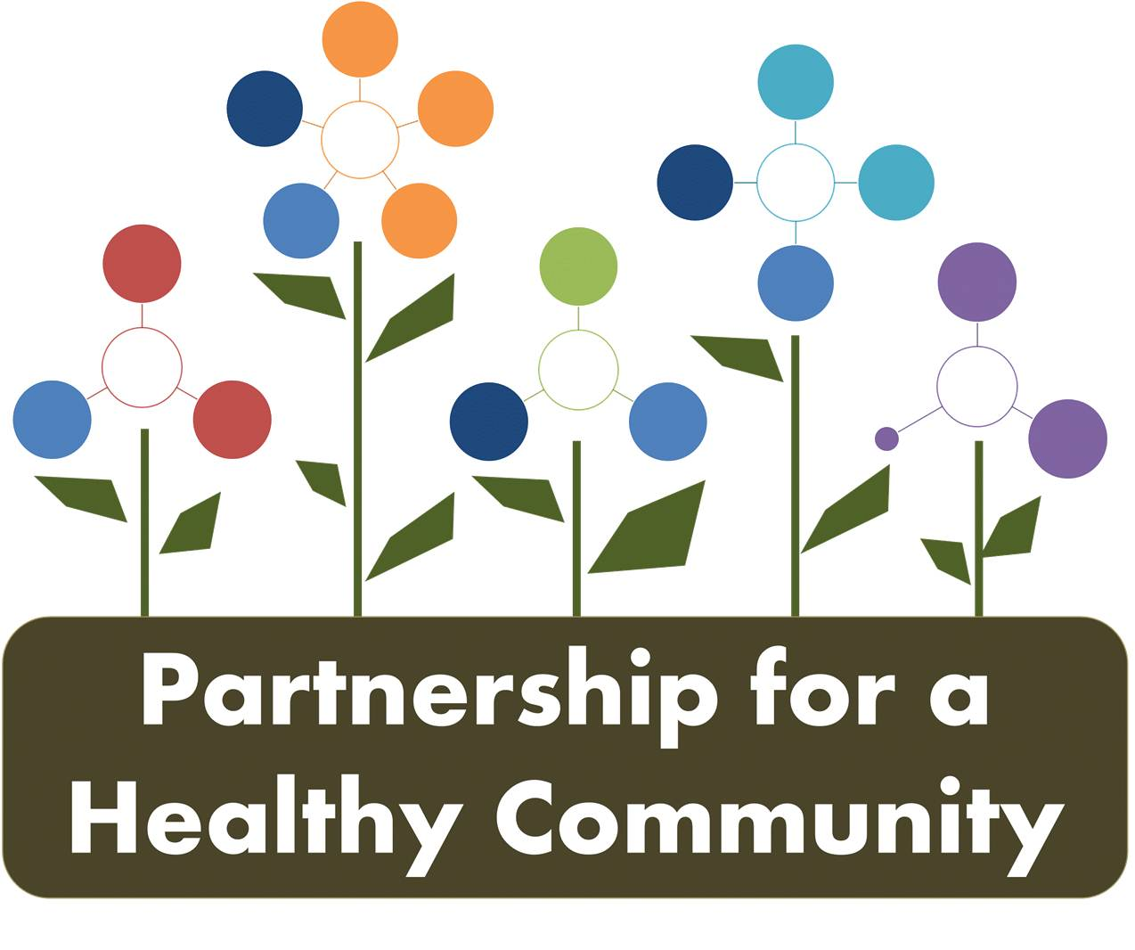
Breast Cancer Committee Meeting
Tazewell County Health Department
October 9, 2018
1:00-2:30
In attendance:
Greg Eberle-Hopedale Wellness/Medical Complex
Donna Long-Unity Point Health Methodist
Gayle Young-Susan G. Komen
Julie Herzog- Tazewell County Health Department
Michelle Hobbs-Tazewell County Health Department
Michele Sharping-Tazewell County Health Department
Beth Scheurmann-Tazewell County Health Department
Andrea Ingwersen, Woodford County Health Department
Hannah Wang-UIC Medical School

Minutes:

Greg Eberle gave the group an update from the Partnership for Health Community board:
- The board is moving towards 501c3 status, so that the board can apply and funnel grants through the Partnership. New officers have been elected and are as follows:
President: Lisa Fuller (OSF)
Co-President: Hillary Aggertt (WCHD)
Vice President: Tim Heth (Unity Point)
Secretary: Amy Fox (TCHD)
- The board discussed marketing for the partnership, currently being done by the 3 HD PIOs but may be more impactful if have one designated person to do marketing. Currently, it is “hit or miss” as far as who is responsible for what. There is a website and Facebook page, Healthy HOI.
- CHNA update-The surveys have been completed and a data committee has been formed. Data analysis should be completed by January 2019, a prioritization team will be formed in spring 2019 and January 2020 will be the next implementation phase. *If the committee has recommendations for the prioritization team, let Greg know.
Quarter 3 Progress was reviewed on the dashboard:
1a.-The MOU has been submitted to OSF Quality Control. Greg noted that Nicole W. rom OSF was cc’d on all correspondence.
1c.-Discussion took place about how exactly to inform providers of the group’s recommendation. Should it be in the form of a letter? A report card of screening numbers/data?
-The committee decided that recommendations would be presented to providers in the form of a letter, on P4HC letterhead, with breast cancer committee participating agencies list on the letterhead. Screening numbers could be included in the correspondence.
Tasks for November meeting -Andrea Ingwersen will create the letterhead and Gayle Young will create the first draft of the letter/report card by the November meeting. The entire committee then can give feedback for the final draft.
1e.-IBCCP working on outreach and increasing number of providers, especially in Woodford, Marshall counties and Hopedale medical Complex. Hopedale has 5 satellite offices now; Tremont, Mackinaw, Manito, Atlanta and Delavan.
- To be an IBCCP provider, have to accept the Chicago Medicare rate.
-Mammo van is no longer in service due to outdated equipment. The mammography machine in the van was 2D and now that is no longer the highest standard of care. 3D is available from all screening providers, and to replace 3D on the mammo van would be too expensive, and equipment is too sensitive to travel, would have to be recalibrated (a time consuming process) each time the van was set up at a stop.
1e. & 1f.-IBCCP presented to approximately 65 women at Daughters of the Elks event. The majority of attendees were African American. Discussion took place on how best to continue to reach this population. Churches and Delta Theta Zeta were both suggested. The sorority has a national platform of promoting breast health.
1e. &1f.-Catalina from Friendship House is now part of the committee and assist with outreach to Hispanic women.
Tasks for November meeting 1.e & 1f.-Michele S. will update IBBCCP caseload and outreach numbers. Donna will give Unity Point screening numbers.
1g.-Backlog is better, TCHD increased number of staff that can bill for IBCCP from 1 person to 3.
1h.-211 discussion, leave listing as is; if search “mammogram” IBCCP is first listing. Individual providers or institutions are responsible for updating their own listing on 211.
Tasks for November meeting –Julie Herzog will reach out to 211, perhaps do a short presentation at December quarterly meeting with both breast and lung cancer committees.

2. - Hopedale, as part of worksite wellness will give extra points in reward system for employees if they are “first time screeners” during October.
The committee continued to discuss outreach barriers, and utilizing all resources available to all programs, such as Health HOI Facebook page.
Events can be submitted by any committee member for the Healthy HOI Facebook page.
Submission for the FB page can go to any of the 3 HD PIOs (give them enough notice) and put it in a format that is easily posted. Ex: a few sentences describing event with a picture, a flyer, etc. Please include date and times. It needs to be easily copied and pasted into FB from an email.
*the committee stopped at 2a.
Next Meeting- Breast Cancer Committee Meeting- November 13th- Woodford County HD 1:002:30pm
Quarterly-Both Breast and Lung Cancer Committee-December 18th-Tazewell County Health Department 2:00-3:30pm

Health Department Conference Lines for call in participants are as follows:
*use the conference call number for the corresponding host site for each meeting
PCCHD number 866-588-5540, Code 556-971-0901
TCHD number 309-670-0444, Code 555
WCHD number 605-468-8004, Code 658044#

