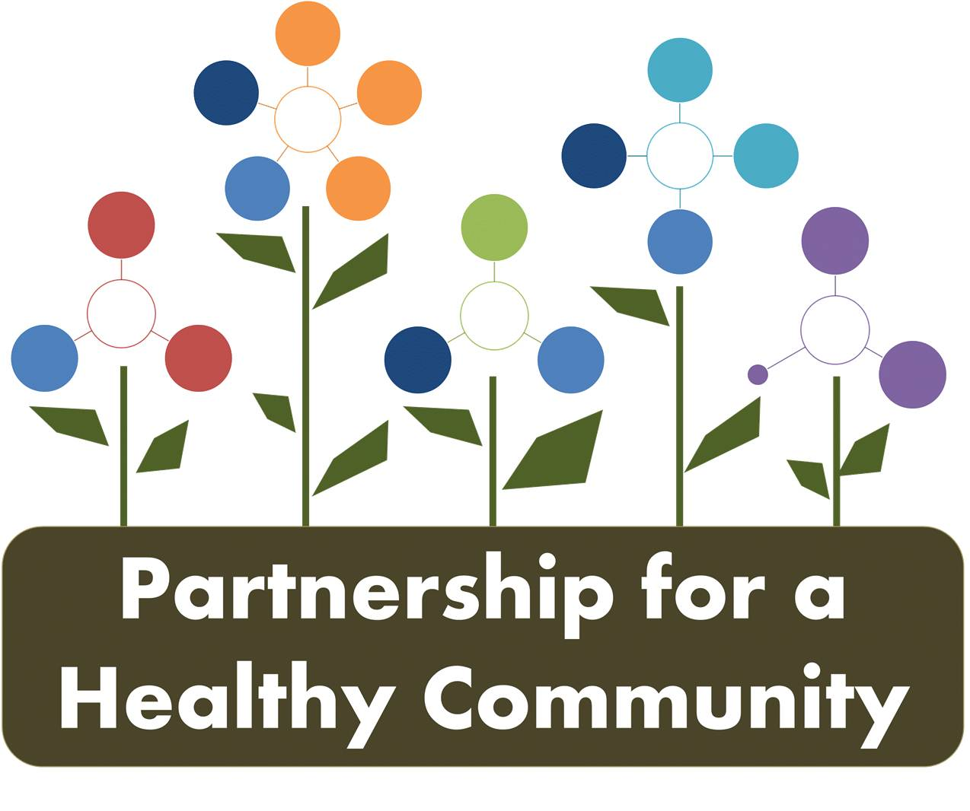
Cancer Committee Meeting
March 20, 2018 1-230
Tazewell County Health Department
Attendees: Evelyn Neavear, Diana Scott, Jenna Tallyn, Donna Long, Diane Hahn, Julie St.Clair, Nathaniel Johnson, Jessica Draper, Julie Angle, Melissa Goetze, Katie Traenkenschun
The group began the meeting with introductions. Diana Scott facilitated the meeting and asked for feedback regarding the annual meeting. Members liked the new website and enjoyed the synopsis of all group operations to date.
Diana Scott provided a dashboard overview of Breast and Lung Cancer dashboards and stated the dashboard is evidence based. Diana asked for feedback and if everything was included. Evelyn stated she liked this format and the goals keep everyone focused and on task long-term.
Diana suggested the lung cancer and breast cancer groups breakout into sessions to discuss their respective dashboards.
The breast cancer group reported discussing specific data needed from hospitals and collaborative efforts in the community to team up with. The group identified community groups and resources as well as targeted populations at risk and how to reach them. They discussed a potential resource guide. There may be some objectives that can be eliminated if approved by the collective group.
**See revised breast cancer dashboard
The lung cancer group reported defining responsible parties for tasks and finalizing tasks and interventions needed for objectives. Evelyn stated the goal of their next meeting will be timelines and indicators. Evelyn also stated that toolkits may be created for outreach at community events. She stated a need for current IEMA data and current law details surrounding objectives.
**See revised lung cancer dashboard
Next meetings:
Breast Cancer: April 10, 2018 from 1-230 at Peoria County Health Department
Lung Cancer: April 11, 2018 from 130-3 at Woodford County Health Department

